1. Create a table named ‘matches’ with appropriate data types for columns

Syntax:

CREATE TABLE matches(

id int,

city text,

date date,

player_of_match varchar,

venue varchar,

netural_venue int,

team1 varchar,

team2 varchar,

toss_winner varchar,

toss_decision varchar,

winner varchar,

result varchar,

result_margin int,

eliminator varchar,

method varchar,

umpire1 varchar,

umpire2 varchar);

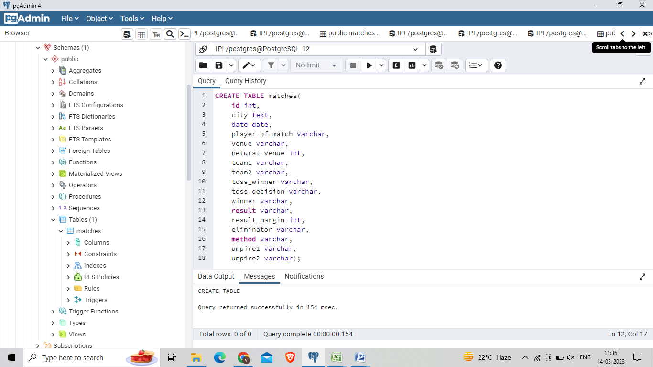

2)

1. Create a table named ‘deliveries’ with appropriate data types for columns

Syntax: CREATE TABLE deliveries(

id int,

inning int,

over int,

ball int,

batsman varchar,

non_striker varchar,

bowler varchar,

batsman_runs int,

extra_runs int,

total_runs int,

is_wicket int,

dismissal_kind varchar,

player_dismissed varchar,

fielder varchar,

extras_type varchar,

batting_team varchar,

bowling_team varchar);

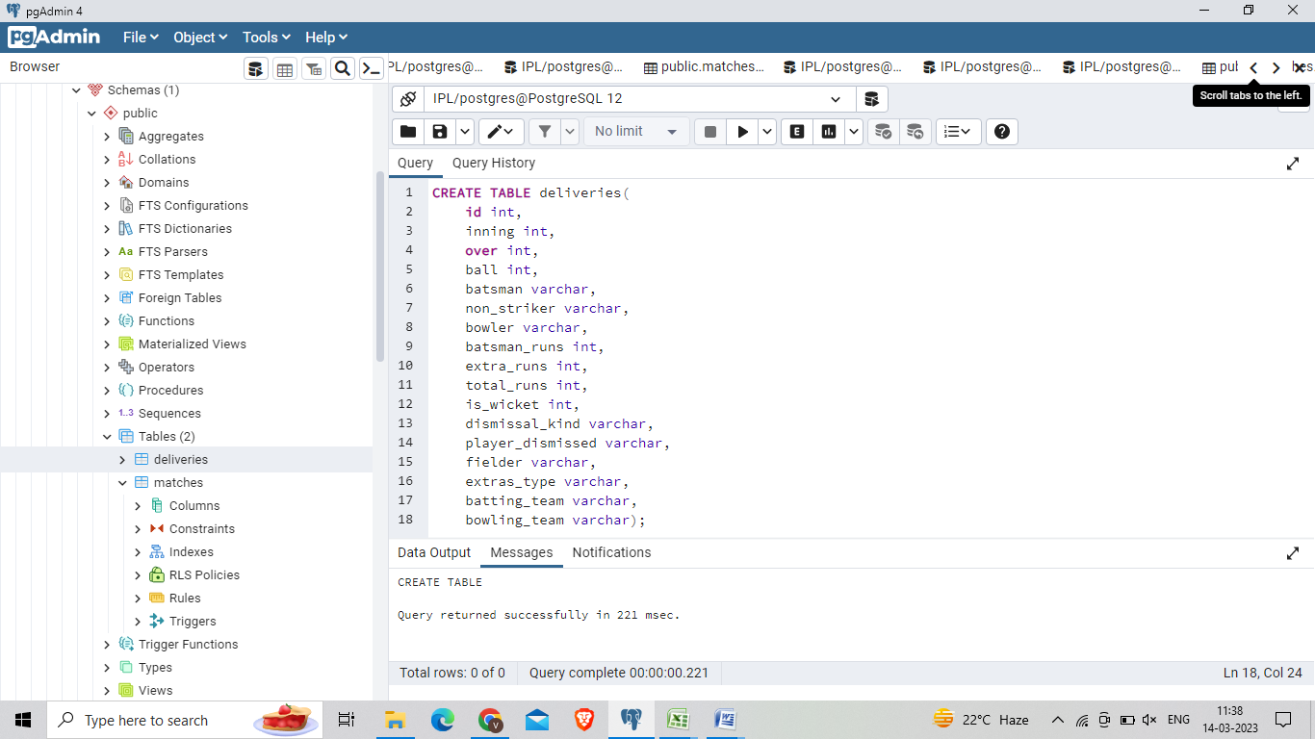

3) Import data from csv file ’IPL_matches.csv’ attached in resources to the table ‘matches’ which was created in Q1

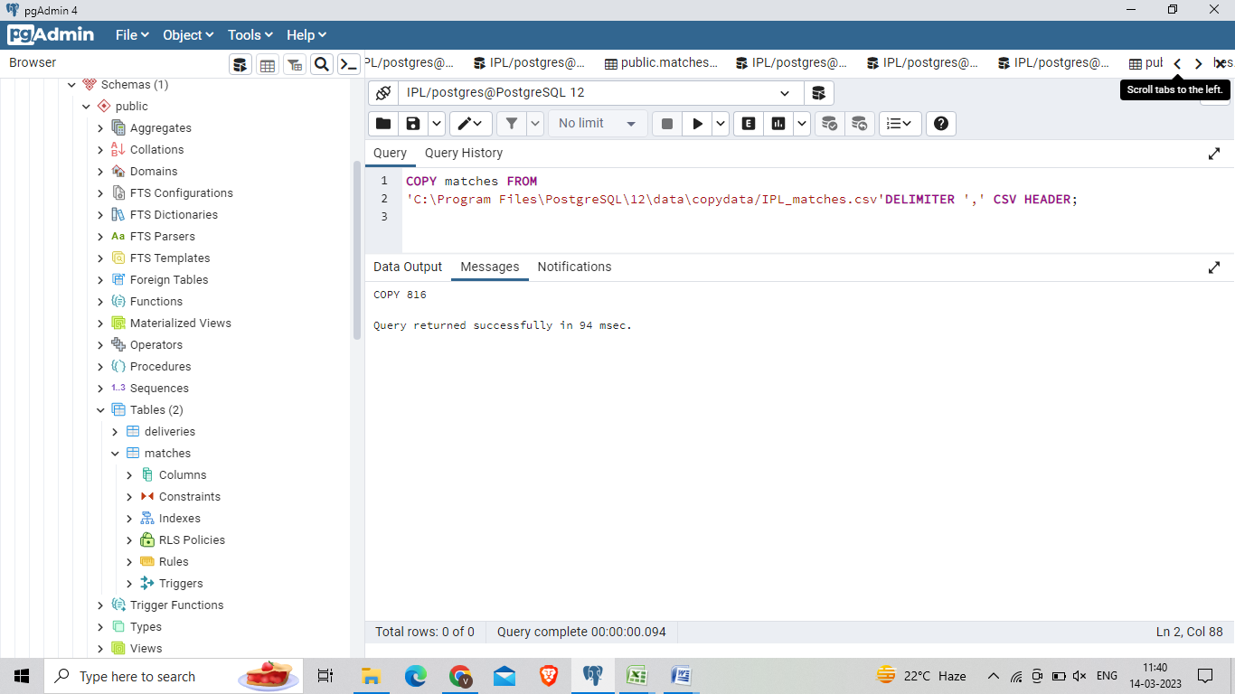

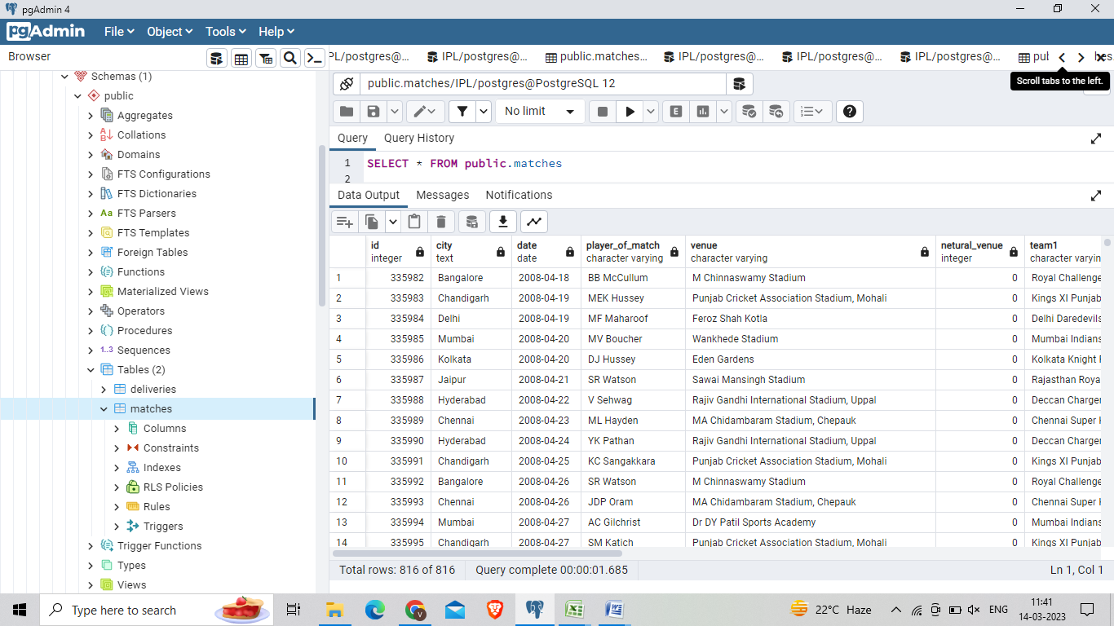

4) Import data from csv file ’IPL_Ball.csv’ attached in resources to the table ‘deliveries’ which was created in Q2

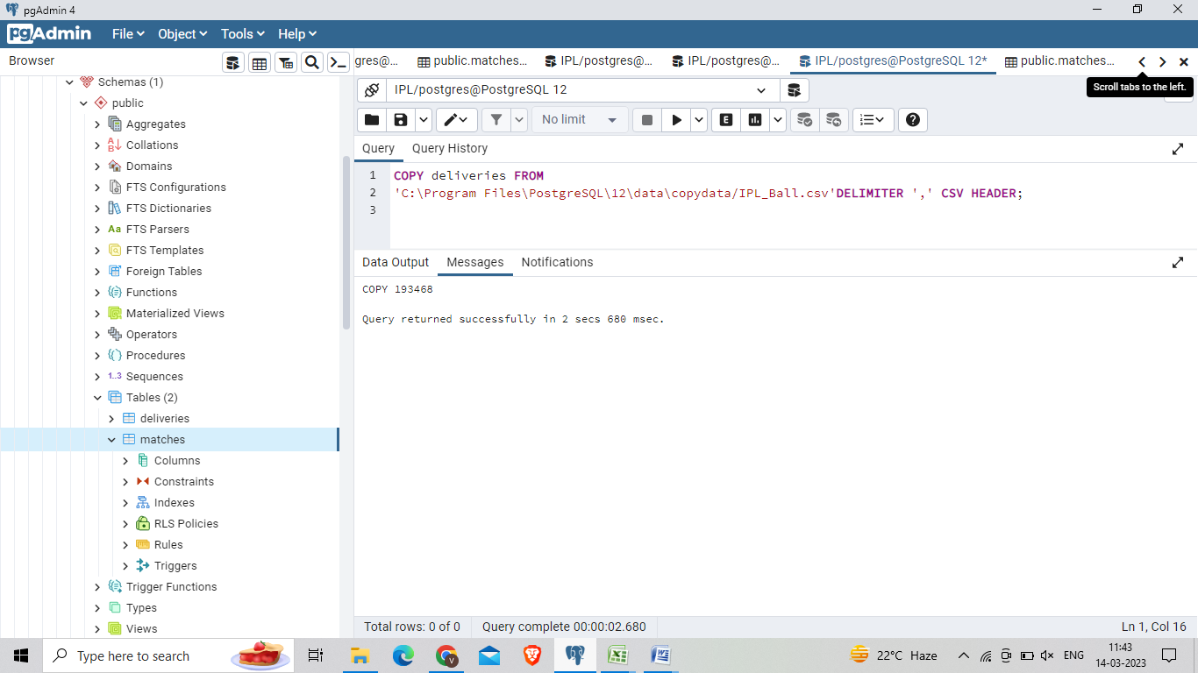

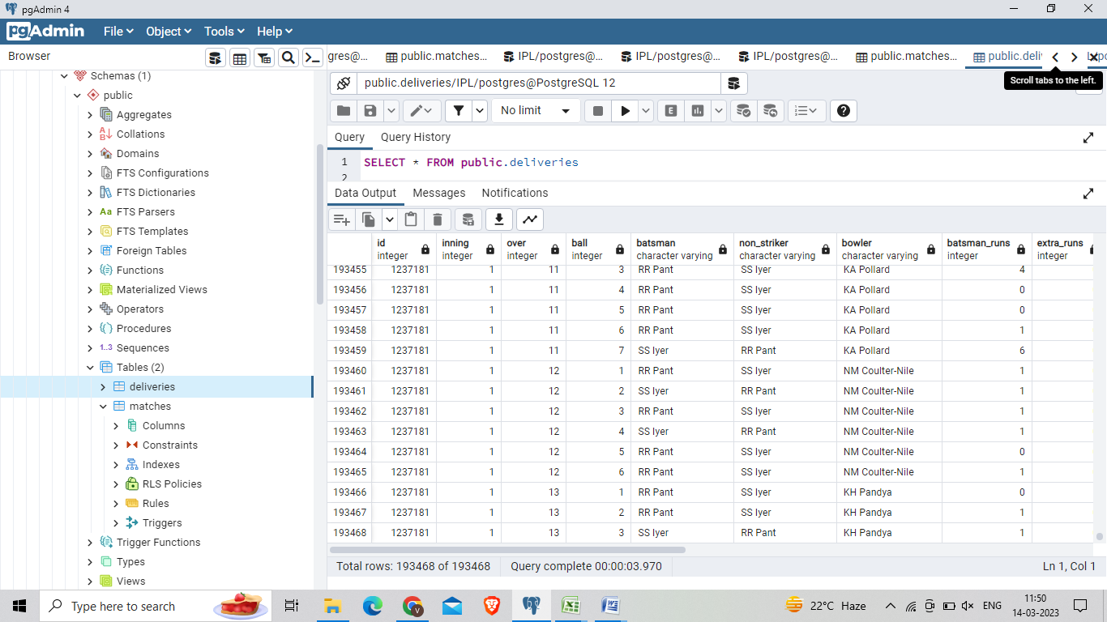

5. Select the top 20 rows of the *deliveries*table after ordering them by id, inning, over, ball in ascending order.

select * from deliveries

order by id, inning, over, ball ASC;

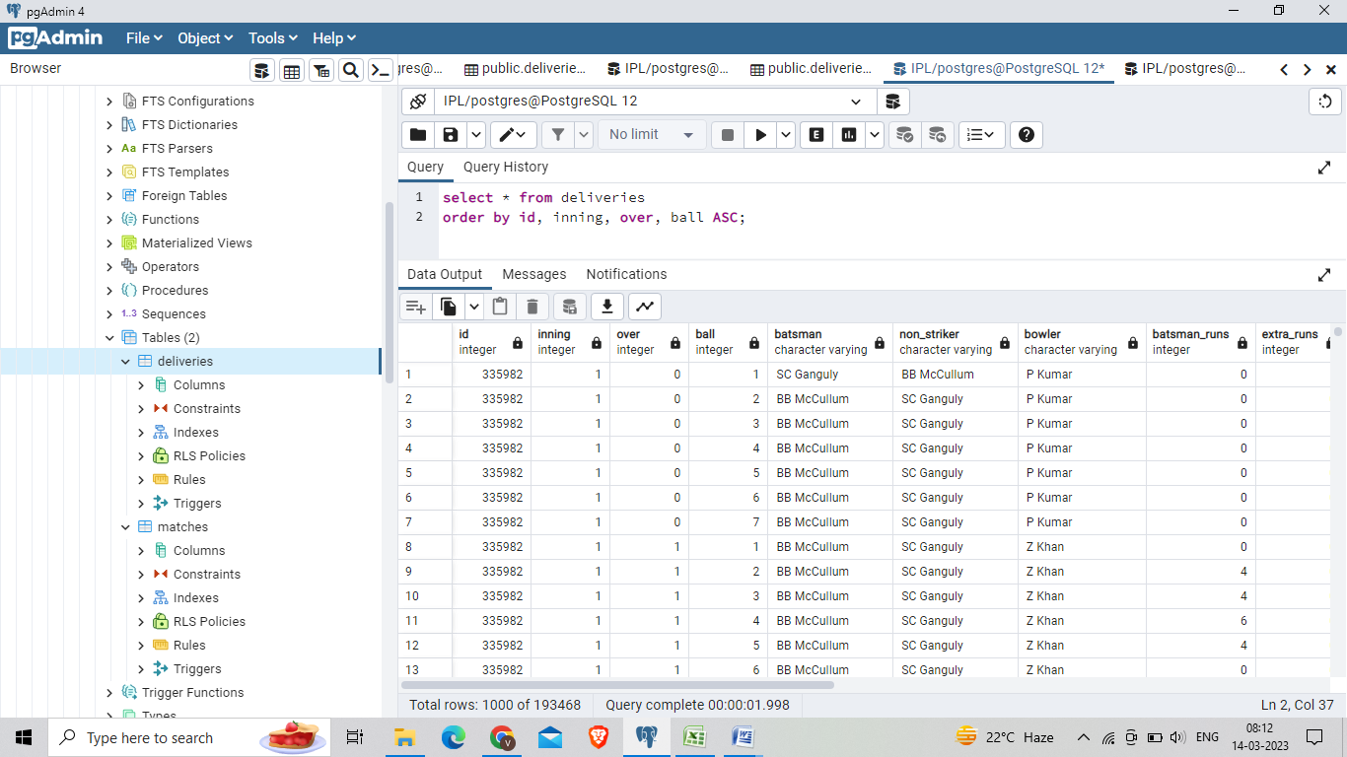

SELECT * FROM deliveries

limit 20;

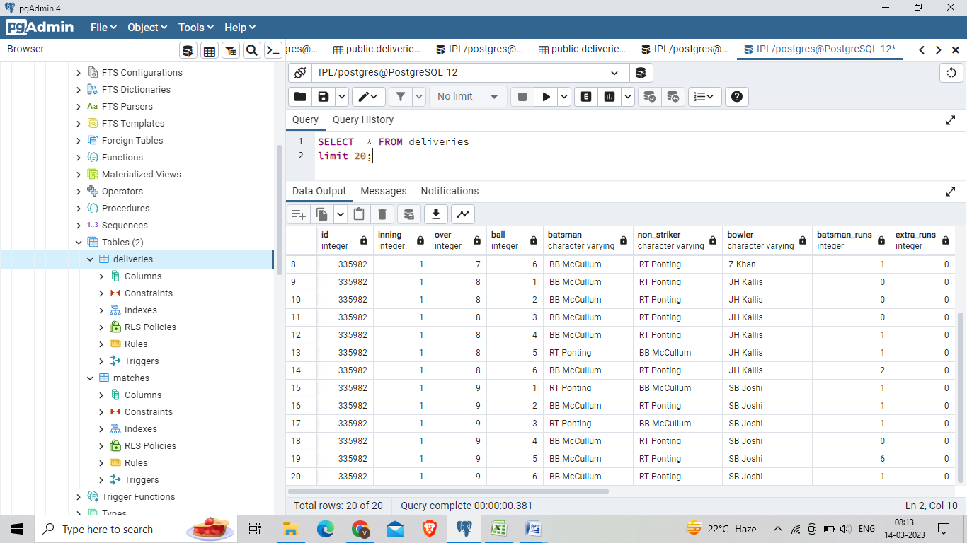

6. Select the top 20 rows of the *matches*table

select * from matches

limit 20;

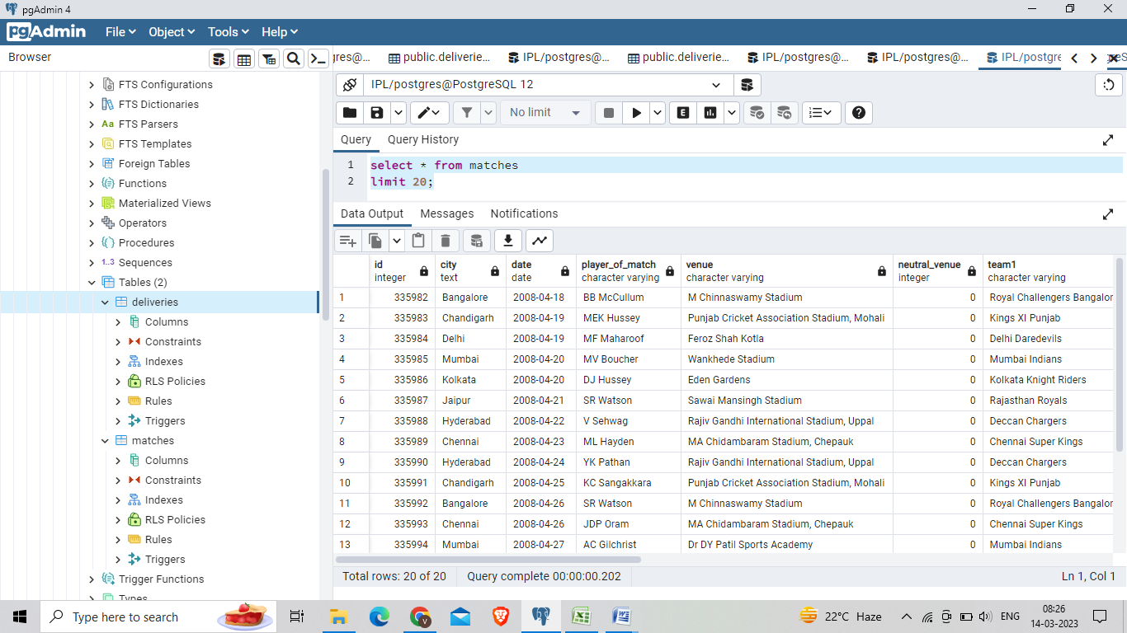

7 Fetch data of all the matches played on 2nd May 2013 from the *matches*table..

select * from matches

where date='02-05-2013';

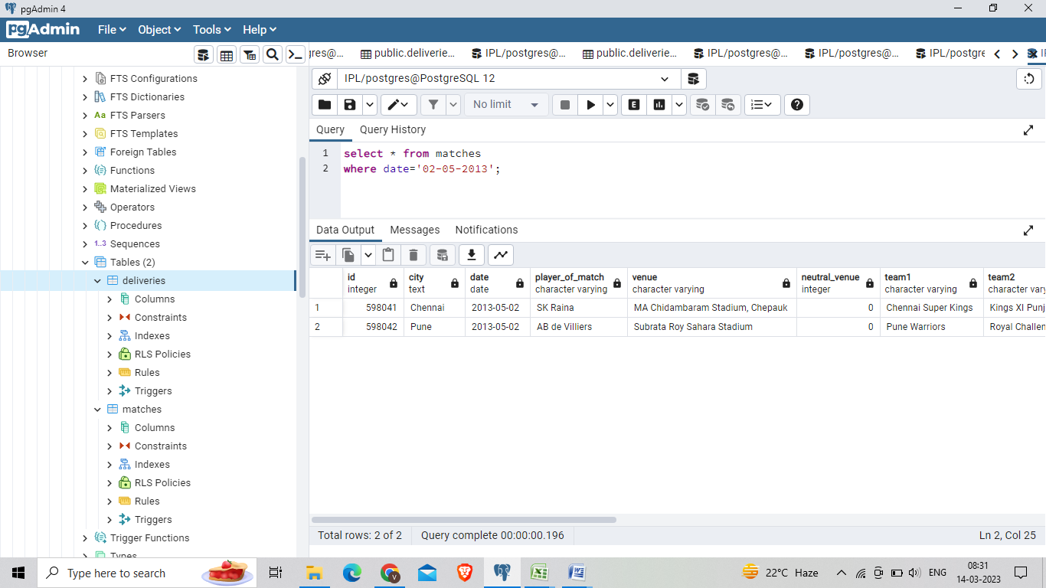

8. Fetch data of all the matches played on 2nd May 2013 from the *matches*table.

Syntax: select * from matches

where result='runs' and result_margin>100

order by result_margin ASC;

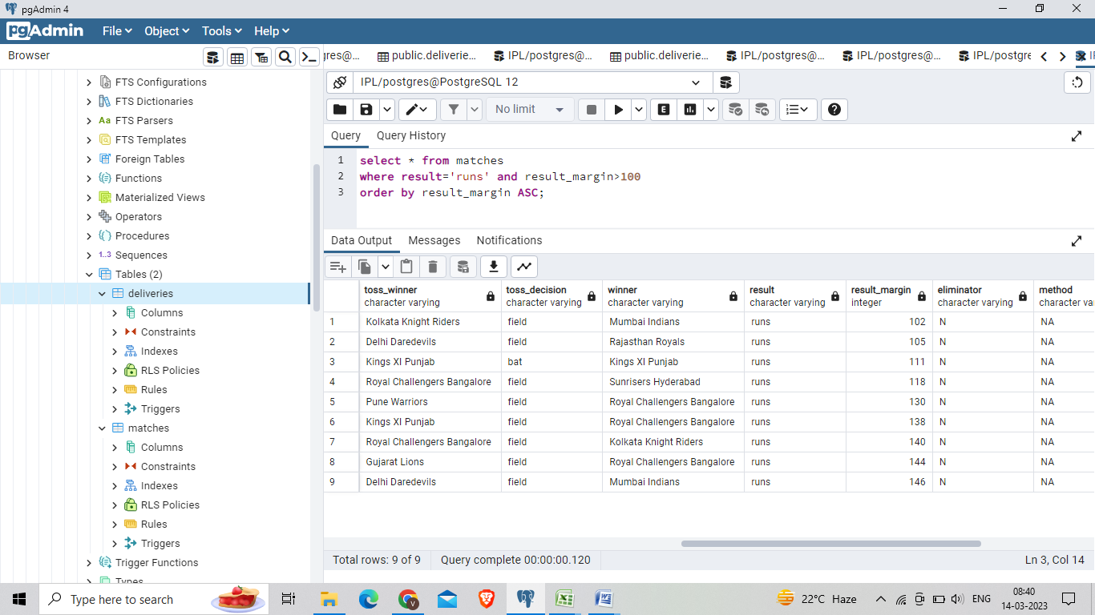

9) Fetch data of all the matches where the final scores of both teams tied and order it in descending order of the date.

method1:

SELECT * FROM matches

WHERE result like '%tie%'

ORDER BY date DESC

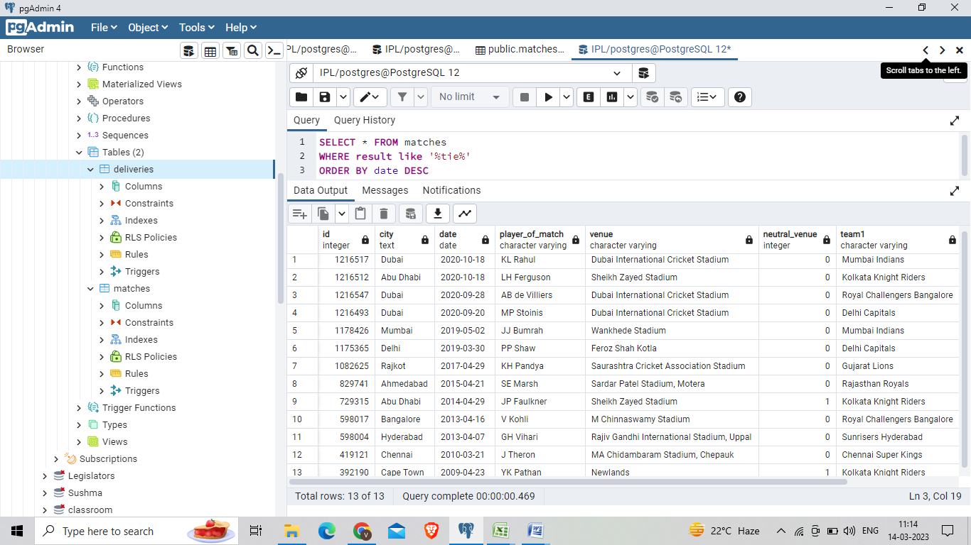

Method 2:

SELECT * FROM matches

WHERE result='tie'

ORDER BY date DESC

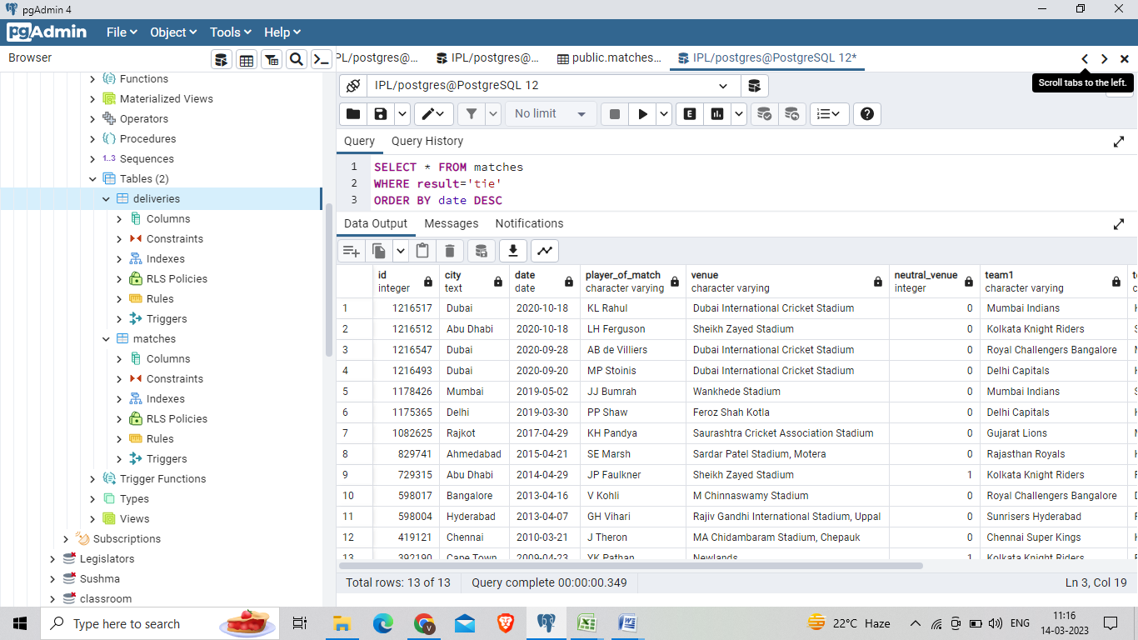

1. 10 Get the count of cities that have hosted an IPL match.

Syntax: select count(city) from matches;

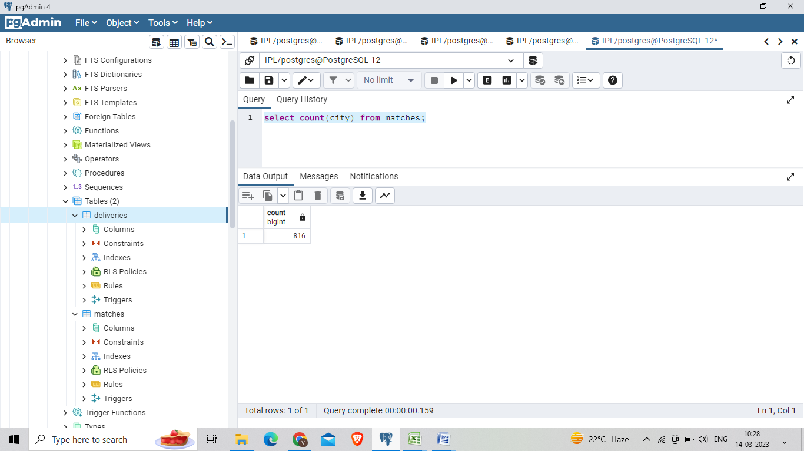

11. Create table *deliveries_v02*with all the columns of the table ‘*deliveries’*and an additional column *ball_result*containing values *boundary*, *dot*or *other*depending on the *total_run*(boundary for >= 4, dot for 0 and other for any other number)  
(Hint 1 : CASE WHEN statement is used to get condition based results)  
(Hint 2: To convert the output data of select statement into a table, you can use a subquery. Create table *table_name*as *[entire select statement].*

Syntax:

CREATE TABLE deliveries_v02 AS

SELECT *,

CASE

WHEN total_runs >= 4 THEN 'boundary'

WHEN total_runs = 0 THEN 'dot'

ELSE 'other'

END AS ball_result

FROM deliveries;

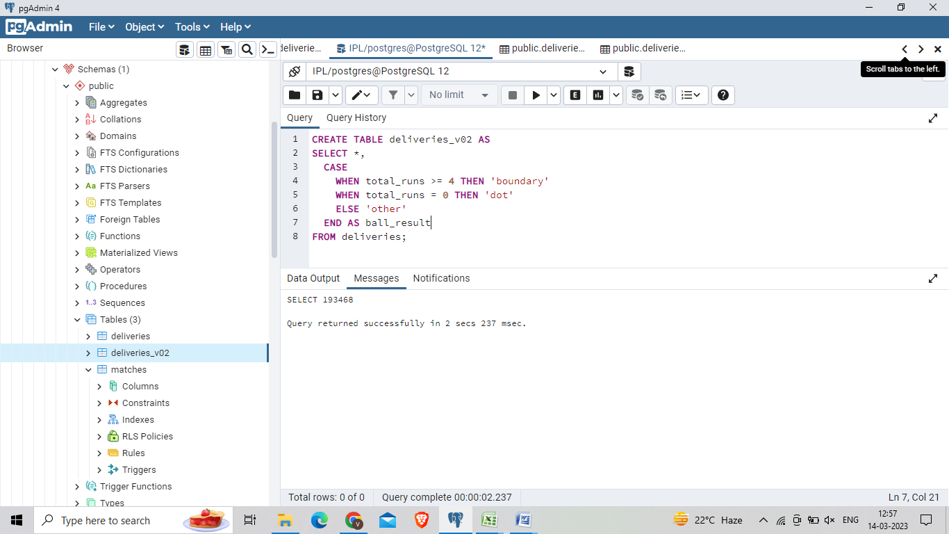

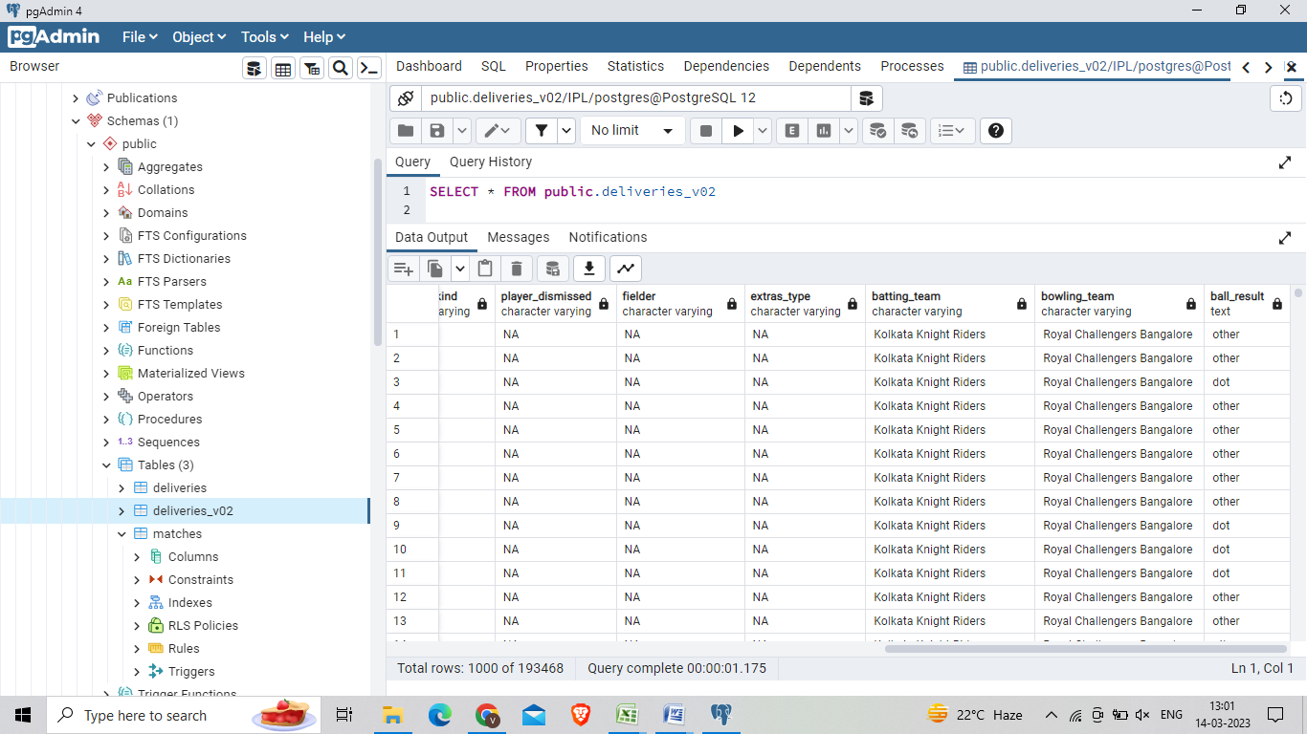

12. Write a query to fetch the total number of boundaries and dot balls from the *deliveries_v02*table.

SELECT ball_result,

COUNT(*) AS total_count

FROM deliveries_v02

WHERE ball_result IN ('boundary', 'dot')

GROUP BY ball_result­­­­­­­­--

